 | Math on Earth
Memo
To: Dr. Laura Perkins
From: Tracy Ann Hardin
cc: Dr. Tamara Blesh
Date: 4/20/2010
Re: Global Educational Networks

Dear Dr. Perkins,

I appreciate your confidence in my by being asked to provide feedback regarding Global Educational Networks. Since our district will likely be implementing the MathOnEarth Initiative in conjunction with educators in India, this feedback will timely in providing additional resources for teachers in launching the mathematical learning modules.

The three resources I have chosen to compare and contrast are as follows:

ePals
- Global Schoolhouse/globalschoolnet.org
- iEARN
The comparison will summarize general characteristics of these resources in a general sense, but then will give more specific recommendations regarding their implementation in the global initiative being considered by the district, MathOnEarth.
The ePals site is likely the easiest resource to implement, because it is simple to use with a very user-friendly screen.
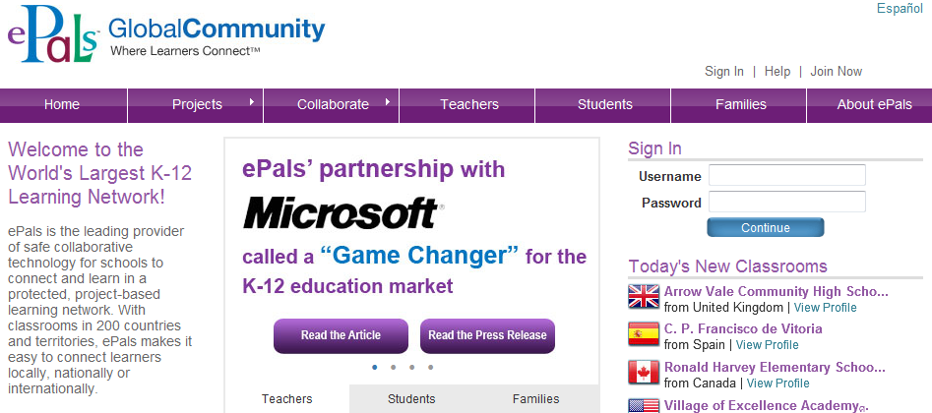
One could essentially log on, sign up and get started at no expense. For the elementary level, this is ideal. It would also be an advisable starting place for teachers who are just getting their feet wet with technology and global learning.
There are a variety of lesson available on ePals, but few involved more advanced mathematics concepts. Implementing epals would not have a relative advantage in supplying alternative project-based math modules requiring critical thinking skills. A positive aspect of ePals is the variety of projects available there which could be used in some capacity in the district or perhaps as a useful link on the teacher page for an idea generator.
Similar to ePals, Global Schoolhouse globalschoolnet.org appears to be an easy to navigate site and does not seem to involve a complicated subscription process or nor does it require a fee.

Also similar to ePals, it seems more appropriate for the elementary or lower middle grades level based on the level of the mathematics lessons available.
Both ePals and Global Schoolhouse are quality products with a variety of opportunities for global connections. As noted in a previous Departmental Memorandum, I feel iEARN will be the most valuable resource for use within the middle grades mathematics department. The main difference was the level of mathematics projects available. It is important to provide the students with projects that are worth it from a technology standpoint, and also those which provide opportunities for critical thinking. The projects on iEARN align most appropriately with these goals.
All three of the global networking sites provide a variety of projects, though iEARN seems to have the greatest variety of quality mathematics projects. Though I would suggest its use over the others in the mathematics department, due to the variety of lesson and project ideas available, I would feel comfortable saying both ePals and GlobalSchoolhouse would be appropropriate resources for any teachers list of favorite web sites.
Sincerely,

Tracy Ann Hardin

REFERENCES
Peters, L. (2009).Connecting global themes to your curriculum. Global education: Using technology to bring the world to your students. (pp. 85) Washington, DC: International Society for Technology in Education.

Dr. Blesh: this is a conference response I made in the classroom which helped me to formulate my opinion on the best of the three global networks, and in the “imaginary” memo, I refer to it as the memo written within my department
DEPARTMENTAL MEMO
Was there a specific network environment that ‘spoke’ to you or had projects that would fit in nicely with your current curriculum?
The iEARN environment, and a mathematics project in particular spoke to me. I am not currently teaching, but it is my desire to teach high school mathematics. Generally, when I am looking for high school mathematics projects and collaboration, I have found them to be few and far between, or launched with dead links.
The project I found was:
Title: Mathematics Virtual Learning Circle
Summary: This project is on an interactive and educational web site about mathematics.
Description: This project is on an interactive and educational web site about mathematics. The main aim of this project is to attract students to different fields of maths and to help teachers with their way of teaching and introducing new interactive teaching styles. Some of the main fields that this site concentrates on are: • Combinatorics and Combinatorial Games • Strategic Games • Geometrical Concepts • Number Theory • Knots Theory • Algorithmic Thinking • Mathematical Logic And Reasoning
- Facilitator(s): Maryam_Behnoudi
- Country: Iran
- Languages: English, Farsi
- Student Age Level: 12-14, 15-18
- Contributions: Bringing students from different cultures and backgrounds together using a common language called mathematics
- Outcomes: To attract students to different fields of maths and to teach them how to think and reason mathematically (iEARN.org, 2010)
The reason this speaks to me, is first and foremost, it’s high school math! Secondly, it has a universal appeal to a country students in the United States may consider enemies, yet they could learn the students there have many similarities to them. Also, it’s interesting to see the language differences in terminology.
Was there a network that looked like you could set up your own project and solicit for classrooms from around the globe to join?
Global Schoolhouse/globalschoolnet.org appears is an easy to navigate site and does not appear to involve a drawn out subscription process or fee.
Would you take the lead and develop a project and if so what might you select from your curriculum to ‘go global’?
Along with my group members in EDTC610, we developed a project which I feel was valuable and would give the students experience in collecting and evaluating data about technology use. The project consisted of two Internet surveys which would be sent out, collected and evaluated. We also set up a blog and a wiki for students to be able to share their experiences with technology, and post survey results. This could be an on-going project, and students could see how technology use changes over time.
Information Literacy
Tech Survey
Peters, L. (2009).Connecting global themes to your curriculum. Global education: Using technology to bring the world to your students. (pp. 85) Washington, DC: International Society for Technology in Education.

